**Lab 3 Deliverables**

Akaash Chikarmane and Milan Feliciello

Section: 16085

Spring 2016

**Schematic**

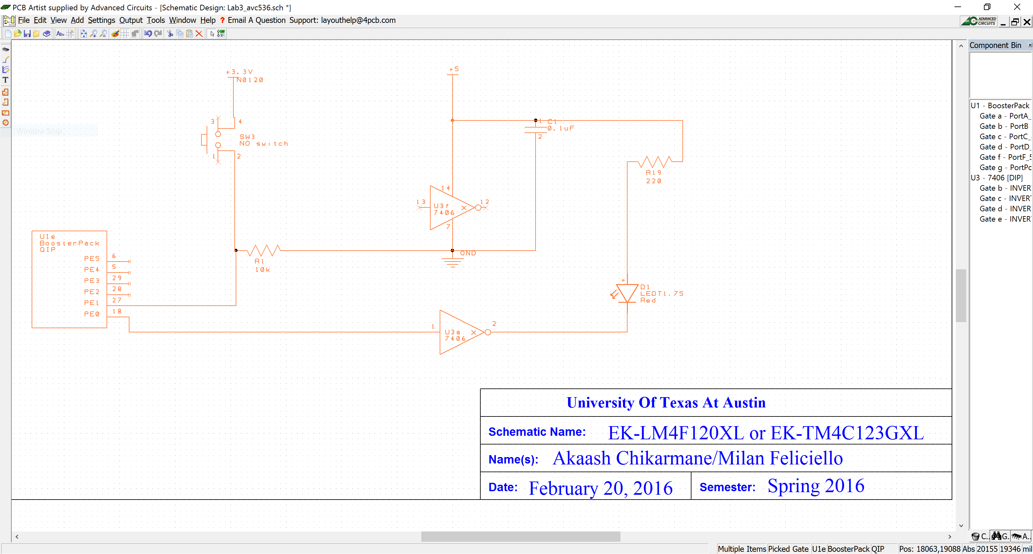

**Delay Screenshot**

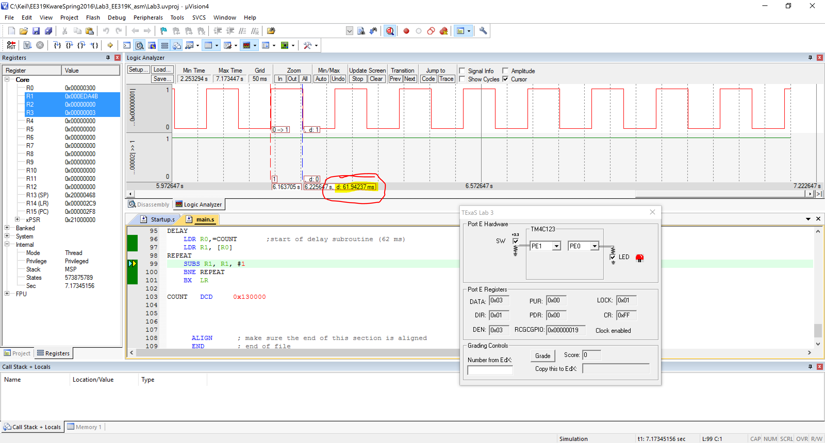

**Table 3.1 (Switch Measurements)**

|  |  |  |  |
| --- | --- | --- | --- |
| Parameter | Value | Units | Conditions |
| Resistance of the  10kΩ resistor, R1 | 9.89 kΩ | ohms | with power off and  disconnected from circuit  (measured with ohmmeter) |
| Supply Voltage, V+3.3 | 3.285 V | volts | Powered  (measured with voltmeter) |
| Input Voltage, VPE1 | 3.4 mV | volts | Powered, but  with switch not pressed  (measured with voltmeter) |
| Resistor current | Calculated: ~ 0.0 mA  Measured: 0 mA | mA | Powered, but switch not pressed  I=VPE1/R1 (calculated and  measured with an ammeter) |
| Input Voltage, VPE1 | 3.28 V | volts | Powered and  with switch pressed  (measured with voltmeter) |
| Resistor current | Calculated: .33 mA  Measured: .33 mA | mA | Powered and switch pressed  I=VPE1/R1 (calculated and  measured with an ammeter) |

**Table 3.2 (LED Measurements)**

|  |  |  |  |  |
| --- | --- | --- | --- | --- |
| Row | Parameter | Value | Units | Conditions |
| 1 | Resistance of the  220Ω resistor, R19 | 219.8 V | ohms | with power off and  disconnected from circuit  (measured with ohmmeter) |
| 2 | +5 V power supply  *V+5* | 5.04 V | volts | (measured with voltmeter relative to ground, *notice that the +5V power is not exactly +5 volts*) |
| 3 | TM4C123 Output, *VPE0*  input to 7406 | 93.7 mV | volts | with **PE0** = 0  (measured with voltmeter relative to ground) |
| 4 | 7406 Output, *Vk-*  LED k- | 3.71 | volts | with **PE0** = 0  (measured with voltmeter relative to ground) |
| 5 | LED a+, *Va+*  Bottom side of R19 | 5.03 | volts | with **PE0** = 0  (measured with voltmeter relative to ground) |
| 6 | LED voltage | 1.32 | volts | calculated as *Va+*- *Vk-* |
| 7 | LED current | .045 | mA | calculated as (*V+5*- *Va+*)/R19  and  measured with an ammeter |
| 0.00 |
| 8 | TM4C123 Output, *VPE0*`  input to 7406 | 3.28 | volts | with **PE0** = 1  (measured with voltmeter relative to ground) |
| 9 | 7406 Output, *Vk-*  LED k- | 128.5 mV | volts | with **PE0** = 1  (measured with voltmeter relative to ground) |
| 10 | LED a+, *Va+*  Bottom side of R19 | 2.055 | volts | with **PE0** = 1  (measured with voltmeter relative to ground) |
| 11 | LED voltage | 1.9265 | volts | calculated as *Va+*- *Vk-* |
| 12 | LED current | 13.58 | mA | calculated as (*V+5*- *Va+*)/R19  and  measured with an ammeter |
| 13.26 |

**Assembly Source Code**

;****************** main.s ***************

; Program written by: Akaash Chikarmane

; Date Created: 1/22/2016

; Last Modified: 2/22/2016

; Section: Tuesday 2-3

; Instructor: Ramesh Yerraballi

; Lab number: 3

; Brief description of the program

; If the switch is presses, the LED toggles at 8 Hz

; Hardware connections

; PE1 is switch input (1 means pressed, 0 means not pressed)

; PE0 is LED output (1 activates external LED on protoboard)

;Overall functionality of this system is the similar to Lab 2, with six changes:

;1- the pin to which we connect the switch is moved to PE1,

;2- you will have to remove the PUR initialization because pull up is no longer needed.

;3- the pin to which we connect the LED is moved to PE0,

;4- the switch is changed from negative to positive logic, and

;5- you should increase the delay so it flashes about 8 Hz.

;6- the LED should be on when the switch is not pressed

; Operation

; 1) Make PE0 an output and make PE1 an input.

; 2) The system starts with the LED on (make PE0 =1).

; 3) Wait about 62 ms

; 4) If the switch is pressed (PE1 is 1), then toggle the LED once, else turn the LED on (0).

; 5) Steps 3 and 4 are repeated over and over

GPIO_PORTE_DATA_R EQU 0x400243FC

GPIO_PORTE_DIR_R EQU 0x40024400

GPIO_PORTE_AFSEL_R EQU 0x40024420

GPIO_PORTE_DEN_R EQU 0x4002451C

GPIO_PORTE_AMSEL_R EQU 0x40024528

GPIO_PORTE_PCTL_R EQU 0x4002452C

SYSCTL_RCGCGPIO_R EQU 0x400FE608

IMPORT TExaS_Init

AREA |.text|, CODE, READONLY, ALIGN=2

THUMB

EXPORT Start

Start

; TExaS_Init sets bus clock at 80 MHz

BL TExaS_Init ; voltmeter, scope on PD3

LDR R0,=SYSCTL_RCGCGPIO_R

LDR R1, [R0]

ORR R1, #0x10 ;enable clock for Port E (0001 0000)

STR R1, [R0]

NOP ;stabilize clock

NOP

LDR R0,=GPIO_PORTE_DEN_R

LDR R1, [R0]

ORR R1, #0x03 ;enable digital I/O for PF3, PF4

STR R1, [R0]

LDR R0,=GPIO_PORTE_DIR_R

LDR R1, [R0]

ORR R1, #0x01 ;PE0=output (1)

BIC R1, #0x02 ;PE1=input (0)

STR R1, [R0]

LDR R0,=GPIO_PORTE_AFSEL_R

LDR R1, [R0]

BIC R1, #0x03 ;no alternate function for PF3,4

STR R1, [R0]

LDR R0,=GPIO_PORTE_DATA_R

LDR R1, [R0]

ORR R1, #0x01 ;LED initially on

STR R1, [R0]

CPSIE I ; TExaS voltmeter, scope runs on interrupts

loop

BL DELAY

LDR R0,=GPIO_PORTE_DATA_R

LDR R1, [R0] ;read the switch (R1 = adjusting PE0)

MOV R2, R1 ;R2 = checking PE1

MOV R3, R1 ;R3 = original data

AND R2, #0x02 ;clear all but PE1

SUBS R2, #0x02

BNE SETON ;if PE1 = 0, turn on LED

AND R1, #0x01 ;clear all but PE0

EOR R1, #0x01 ;toggle PE0

BIC R3, #0x01 ;clear original PE0

ORR R3, R1, R3 ;recombine

STR R3, [R0]

B loop

SETON

ORR R3, #0x01

STR R3, [R0]

B loop

DELAY

LDR R0,=COUNT ;start of delay subroutine (62 ms)

LDR R1, [R0]

REPEAT

SUBS R1, R1, #1

BNE REPEAT

BX LR

COUNT DCD 0x130000

ALIGN ; make sure the end of this section is aligned

END ; end of file